An Assessment of the Differences Between Three

Satellite Snow Cover Mapping Techniques

David Bitner, Tom Carroll¹, Don Cline¹, and Peter Romanov

ABSTRACT

The National Operational Hydrologic Remote Sensing Center (NOHRSC), National Weather Service (NWS), National Oceanic and Atmospheric Administration (NOAA) provides daily satellite-derived snow cover maps to support the NWS Hydrologic Services Program covering the coterminous U.S. and Alaska. This study compared the NOHRSC snow cover maps with new automated snow cover maps produced by the National Environmental Satellite, Data, and Information Service (NESDIS) and the snow cover maps created from the Moderate Resolution Imaging Spectroradiometer (MODIS) imagery. The purpose of this paper is to demonstrate and account for the differences that occur between the three different snow cover mapping techniques. Because each of these snow cover products uses data from different sensors at different resolutions, the data were degraded to the coarsest relevant resolution. In both comparisons, forest canopy density was examined as a possible explanatory factor to account for those differences. NOHRSC snow cover maps were compared to NESDIS snow cover maps for 32 different dates from November 2000 to February 2001. NOHRSC snow cover maps were also compared to MODIS snow cover maps in the Pacific Northwest and the Great Plains for 18 and 21 days, respectively, between March 2001 and June 2001. In the first comparison, where the NOHRSC product (~1 km) was degraded to match the resolution of the NESDIS data (~5 km), the two products showed an average agreement of 96%. Forest canopy density data provided only weak explanation for the differences between the NOHRSC and the NESDIS snow cover maps. In the second comparison, where the MODIS product (~500 m) was degraded to match the resolution of the NOHRSC product for two sample areas, the agreement was 94% in the sample area in the Pacific Northwest, and 95% in the sample area in the Great Plains.

Keywords: remote sensing, snow

INTRODUCTION

Snow cover maps are used operationally within NOAA for input into both climatic and hydrologic models (Cline and Carroll, 1999). Different applications within the agency require snow cover maps with different spatial resolutions and geographic extents. Consequently, different snow cover products are produced within the agency. The NOHRSC has been mapping the areal extent of snow cover using a semi-automated approach with Geostationary Operational Environmental Satellite (GOES) and Advanced Very High Resolution Radiometer (AVHRR) data since 1986 at a nominal resolution of 1 km. These maps are used by the NWS Hydrologic Services Program. Beginning in the winter of 1998-1999, NESDIS began mapping snow cover daily at a nominal resolution of 5 km using a combination of GOES and Special Sensor Microwave/Imager (SSM/I) data to create cloud-free snow maps (Romanov, Gutman, and Csiszar 1999). This was done to create a higher resolution, automatic method to replace their nominal 40-km resolution manual snow cover maps that are used for input into weather prediction models. With the launch of the Earth Observing System (EOS) Terra satellite and the MODIS sensor in 1999, NASA began to process daily snow cover maps at a nominal resolution of 500 m for research purposes (Hall, Riggs, and Salomonson, 2001).

This paper quantifies the differences between the NOHRSC snow cover product and the NESDIS and MODIS snow cover products for cloud free areas. NOHRSC snow cover maps for the coterminous U.S. were compared with NESDIS automated snow cover maps for 32 dates between November 2000 and February 2001. NOHRSC snow cover maps were also compared with MODIS snow cover maps over two areas in the northwest and north central U.S. (Figure 1) corresponding to MODIS granules. For this study, these two areas were called the northwest and the plains study areas. For the northwest study area, comparisons were made for 18 dates between March and June 2001. For the plains study area, comparisons were made for 21 dates between March and June 2001. Classification of optical remote sensing data to produce snow cover maps inherently requires techniques to discriminate snow on the ground from cloud cover. In this study, only cloud-free areas in both maps were evaluated to eliminate discrepancies due to different image acquisition times and different cloud screening techniques.

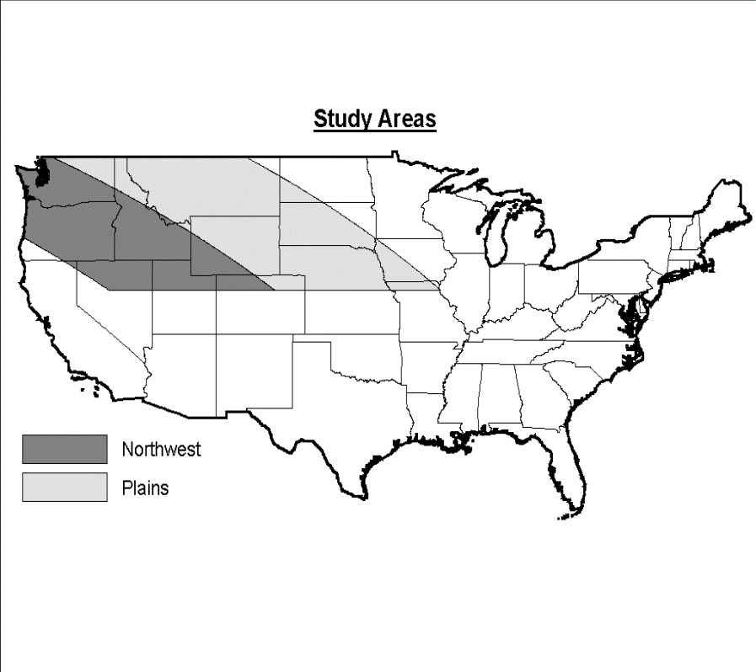

Figure 1. Study Areas used in snow cover comparisons. NOHRSC/NESDIS comparisons were made for the entire coterminous U.S. NOHRSC/MODIS comparisons were made for the Northwest and Plains study areas only.

There have been many recent studies evaluating snow cover mapping techniques using satellite-derived data (e.g. Romanov, Gutman, and Csiszar 1999; Maurer et al., 2002; Hall et al., 2000). These studies have used various techniques to evaluate the accuracy of satellite-derived snow cover maps. In preparation for the launch of MODIS on the EOS Terra satellite, Landsat Thematic Mapper data were used to try to estimate what type of results could be expected from the new sensor (Hall et al., 2000). To verify the snow cover maps from the NESDIS automated snow mapping system, point data of snow measurements were used to measure the hits and misses of snow cover (Romanov, Gutman, and Csiszar, 1999). Maurer, et al. Compared 1-km data from the NOHRSC with 500-m data from MODIS (2002). All of these studies demonstrated several difficulties in evaluating satellite-derived snow cover. For example, using data from different sensors with different resolutions lead to difficulty in creating smoothing effects due to resampling (Maurer, et al., 2002; Hall, et al., 2000). The use of point data to evaluate satellite-derived snow cover was problematic because of the limited coverage and density of ground truth data (Romanov, Gutman, and Csiszar, 1999).

This study evaluated the differences between three different satellite snow cover mapping techniques involving different spatial resolutions. This paper was not intended to assess which of the three techniques creates the better snow cover map. Rather, the purpose of this paper was to evaluate the differences between snow cover mapping techniques, and to attempt to explain these differences. Understanding why these differences occur should be useful for evaluating other techniques or developing new techniques.

BACKGROUND

The snow maps compared in this study were produced using three distinct methods. The NOHRSC uses optical data and a supervised classification technique that requires substantial manual interpretation of imagery. Snow cover cannot be estimated beneath obscuring cloud cover using optical data alone. NESDIS employs automated image classification methods using both optical and microwave data. They incorporate the snow cover information derived from microwave data only in those areas where the ground is obscured by cloud. NASA snow maps are based on MODIS data alone (i.e. Optical), and are also produced using an automated classification technique. The separation of snow cover from clouds, a basic requirement of snow cover classifications using optical data, is also handled differently in each of these three snow mapping techniques.

NOHRSC Snow Maps

The NOHRSC has been mapping the snow covered area of the coterminous U.S. using AVHRR and GOES image data operationally since 1986. Since 1996, the NOHRSC has created daily, national gridded products that are made available the day after the observations are made. Currently, the NOHRSC creates the daily (Monday - Friday) maps using two images each day: one from GOES 10 to cover the western United States (between 16 and 18z (Greenwich Mean Time)), and one from GOES 8 to cover the eastern United States (between 14 and 16z). The GOES visible band (band 1, 0.55-0.75 µm) is used at its nominal resolution of 1 km. The thermal bands (band 2, 3.80-4.00 µm, band 4, 10.20-11.20 µm, and band 5, 11.50-12.50 µm) are resampled from 4-km to 1-km resolution. These images are automatically georegistered and solar-normalized at the NOHRSC in preparation for classification. Beginning in March 2001, an additional preprocessing step was implemented to correct for parallax displacement in the GOES images. Each image is mapped by NOHRSC analysts using a supervised image classification technique (Cline and Carroll, 1999). The two resulting maps are mosaicked to produce one daily snow cover map for the coterminous U.S. at a resolution of 30 arc seconds (~1 km). NOHRSC products are made available by ftp by the next morning.

NESDIS Snow Maps

NESDIS began mapping the snow covered area of the northern hemisphere using an automated snow mapping algorithm in the winter of 1998-1999. The snow maps have a nominal resolution of 5 km, and are input into the National Center for Environmental Prediction's numerical weather prediction models. These maps are created by compositing GOES 8 and GOES 10 bands 1, 2, and 4 over several daylight hours for each day to create a single composite image with an increased number of cloud-free pixels. This composite image is classified using an automated decision tree approach (Romanov, Gutman, and Csiszar 1999). Snow cover in areas obscured by cloud in the resulting map is estimated using passive microwave data (SSM/I) with a nominal resolution of 23 km. NESDIS products are also available by ftp the next morning.

MODIS Snow Maps

NASA began mapping global snow cover in the winter of 2000-2001 using newly available MODIS data and an automated classification algorithm. The MODIS sensor has higher spectral and spatial resolution than that of the GOES imagery used by both the NOHRSC and NESDIS (36 bands at 250-500 m and 4 bands at 1-4 km). The SNOWMAP routine uses five of the available visible and near-infrared MODIS bands to map snow. To differentiate between land and snow, a Normalized Difference of Snow Index (NDSI) is created as the sum of MODIS bands 4 (0.545-0.565 µm) and 6 (1.628-1.652 µm) over the difference of bands 4 and 6. Because it is often difficult to identify snow under forest canopy cover, a Normalized Difference of Vegetation Index (NDVI) is created using MODIS bands 1 (0.620-0.670 µm) and 2 (0.841-0.876 µm) to indicate the presence of forest cover. The threshold NDSI value is varied as a function of the NDVI (Hall, Riggs, and Salomonson, 2001). As an additional check, MODIS band 31 (10.780-11.280 µm) is used as an indicator of surface temperature to filter out the possibility of snow in tropical areas. MODIS snow cover products are considered experimental and are generally not available until several days after data collection.

METHODS

For this study, three different comparisons were performed. The first comparison was between the NESDIS snow cover maps and the NOHRSC snow cover maps generated for the coterminous U.S. The second and third comparisons were between the NOHRSC snow cover maps and MODIS snow cover maps for each of the two adjacent granules that cover the area in the northwestern U.S. Differences in resolution, image geometry, and other product characteristics required different methods of preparation for each set of products.

Data Acquisition

All NOHRSC data were acquired in latitude/longitude coordinates from data archives at the NOHRSC (http://www.nohrsc.nws.gov). NESDIS data were acquired in latitude/longitude coordinates from the NESDIS ftp site (http://orbit-net.nesdis.noaa.gov/crad/sat/surf/snow/HTML/snow.htm). For the NOHRSC/NESDIS comparisons, only dates prior to March 2001 were used to avoid disagreements caused by differences in spatial registration between parallax-corrected NOHRSC imagery and parallax-uncorrected NESDIS imagery (Table 1). MODIS data were ordered through the National Snow and Ice Data Center (http://nsidc.org/data/modis/data.html) and downloaded from their ftp server. These data were reprojected into latitude/longitude coordinates using the MODIS reprojection tool (http://edcwww.cr.usgs.gov/programs/sddm/modisdist/index.shtml). The effects of parallax were assumed to be small in the MODIS imagery because of its near-nadir view, so comparisons were made for dates beginning in March (Table 1).

NOHRSC-NESDIS | NOHRSC-MODIS Plains | NOHRSC-MODIS Northwest
2000-November-1,3,7,14,21,24,28 | 2001-March-9,13,16,20,23,27,30 | 2001-March-12,16,23,26,30
2000-December-1,5,8,12,15,19,22,29 | 2001-April-13,17,24,27 | 2001-April-10,16,17,23,24,27
2001-January-2,5,9,12,16,19,23,26,30 | 2001-May-1,4,8,11,15,18,22,25,29 | 2001-May-1,4,8,11,22,25
2001-February-2,6,9,13,16,20,23,27 | 2001-June-1 | 2001-June-1
Total = 32 | Total = 21 | Total = 18
Table 1. Dates used for comparison.

Resampling

In each comparison, the snow maps were first resampled to the lowest common resolution. To minimize the effects of resampling on the subsequent comparisons, all high-resolution pixels corresponding to a particular coarse-resolution pixel were required to be of the same category. If this condition was not met, the resampled pixel was assigned a no-data value and was not considered in the comparison. Thus the resampling to coarser resolution filtered out all cases of mixed pixels identified by the finer resolution. For example, in the NOHRSC/NESDIS comparisons, the NOHRSC map was resampled from about 1-km resolution to match the 5-km resolution of the NESDIS map (Figure 2). For the resampling, the geometric area defined by each pixel in the NESDIS map contained the centerpoints of between 16 and 25 NOHRSC pixels. If all these pixels contained the same values (for example, snow), the pixel in the resampled map was given the value snow. If these pixels did not all have the same value, the pixel in the resampled map was given the value "no-data". In the NOHRSC/NESDIS comparisons, all of the NOHRSC maps were resampled to a nominal resolution of 5 km. In the NOHRSC/MODIS comparisons, all MODIS data were resampled to a nominal resolution of 1 km.

Figure 2. Data were resampled by locating which cells in the finer resolution grid (in this case, the NOHRSC at 1km) contained centerpoints within the bounds of the coarser grid (the NESDIS at just under 5km). If all of the NOHRSC cells had the same value (as in the figure on the left) the resampled grid was given that value. If all the NOHRSC cells falling within the bounds of a NESDIS cell were not homogenous (as in the figure on the right), the resampled grid was given the no-data value.

Map Comparison

With each pair of snow maps in the same resolution and projection, a comparison map was created. Only pixels with categories of snow and snow-free were compared. Pixels with categories of cloud in either map were ignored in the comparison. For each pair of snow maps compared, an image was produced indicating the type of agreement or disagreement for each pixel. These images were summarized to determine the percent overall agreement, percent where both maps indicated snow cover, percent where both indicated snow-free, percent where each disagreed as to the presence of snow, and the KHAT statistic. The KHAT statistic measures the proportion of correctly classified pixels after the probability of chance agreement has been removed (Congalton, 1991). Dates where there was greater than 80% cloud cover in the NOHRSC snow cover map were not analyzed. This ensures the results were not skewed by the small sample size.

Forest Cover

The comparisons were analyzed to evaluate the agreement and disagreement within different ranges of forest canopy density. The USDA forest canopy density map (Zhu and Evans, 1994) was used. At its 1 km resolution, this map was incorporated directly into the NOHRSC/MODIS comparisons. For the NOHRSC/NESDIS comparison, this map was resampled to match the nominal 5km resolution of the NESDIS map. This new forest density was created by taking the average forest density of the finer resolution image. For both resolutions, the maps were reclassified into the following classes: less than 25% forest cover, 25%-50% forest cover, 50%-75% forest cover, and greater than 75% forest cover. The same statistics were calculated for each date and for each classification of forest cover.

RESULTS

NOHRSC-NESDIS Snow Cover Map Comparison

There was very good agreement (95.9%) between the snow cover maps when compared at 5 km resolution (Table 2). The similarity of results between these methods was also shown by the high value of the KHAT statistic (89.7%), indicating the agreement after the probability of chance agreement has been removed. For the overall maps, NESDIS consistently mapped more snow than the NOHRSC. On average, 3.7% of all pixels were mapped as snow in the NESDIS maps that were mapped as snow-free in the NOHRSC maps. Only 0.4% of all pixels were mapped by the NOHRSC as snow that NESDIS had mapped as snow-free. There was little difference found between the agreements or KHAT statistics with respect to the forest cover classes.

 | Percent Agreement | KHAT Statistic | Percent of pixels NESDIS snow/ NOHRSC Bare Land | Percent of Pixels NOHRSC Snow/ NESDIS Bare Land
Overall | 95.9 | 89.7 | 3.7 | 0.4
<25% Forest | 96.0 | 89.5 | 3.6 | 0.4
25%-50% Forest | 96.1 | 89.5 | 3.4 | 0.5
50%-75% Forest | 95.3 | 87.1 | 4.3 | 0.4
>75% Forest | 95.6 | 88.0 | 3.8 | 0.6
Table 2. Summary of comparisons between NOHRSC and NESDIS snow cover maps showing agreement, KHAT statistic, and individual disagreements between the overall snow cover comparisons and the comparisons stratified by percent forest cover.
NOHRSC-MODIS Snow Cover Map Comparison

The comparisons between NOHRSC snow cover maps and the two MODIS study area maps showed very similar results. The average agreement between the NOHRSC snow cover maps and the MODIS snow cover maps in the plains and northwest was very good. The snow cover maps showed a 95.1% (plains) and 94.2%(northwest) agreement when compared at 1 km resolution (Tables 3 and 4). This was tempered by the KHAT statistic that indicates that only 51.3% and 56.2% of the agreement is not due to chance. The average KHAT statistic was reduced because in several of the dates, the total disagreement was similar to the percent of snow mapped by both NOHRSC and MODIS. This occurred when the total snow amount seen in a given image is small. For instance, in the March 26, 2001 comparison for the northwest (Table 5), despite an overall agreement of 96.9%, the KHAT statistic was only 51.6%. In this case, only 1.7% of pixels were mapped as snow by both NOHRSC and MODIS while 3.1% of pixels disagreed.

The agreement between the NOHRSC and MODIS snow cover maps for both areas diminished as the percent of forest cover increased. As the percentage of forest cover increased, so too did the percentage of pixels in the snow cover map that were classified in the MODIS snow cover maps as snow but were classified in the NOHRSC maps as snow-free. Likewise, the percentage of pixels in the image that were classified by MODIS as snow-free and by the NOHRSC as snow diminished as forest cover increased.
 | Percent Agreement | KHAT Statistic | Percent of pixels MODIS plains snow/ NOHRSC bare land | Percent of pixels NOHRSC snow/ MODIS plains bare land
Overall | 95.1 | 51.3 | 2.3 | 2.6
<25% Forest | 96.7 | 54.1 | 0.6 | 2.7
25%-50% Forest | 96.1 | 58.6 | 0.8 | 3.1
50%-75% Forest | 87.4 | 40.1 | 11.1 | 1.6
>75% Forest | 74.8 | 16.1 | 24.5 | 0.6
Table 3. Summary of comparisons between NOHRSC and MODIS plains snow cover maps showing agreement, KHAT statistic, and individual disagreements between the overall snow cover comparisons and the comparisons stratified by percent forest cover.
 | Percent Agreement | KHAT Statistic | Percent of pixels MODIS northwest snow/ NOHRSC bare land | Percent of pixels NOHRSC snow/ MODIS northwest bare land
Overall | 94.2 | 56.2 | 3.0 | 2.8
<25% Forest | 96.5 | 43.0 | 0.7 | 2.8
25%-50% Forest | 93.1 | 62.8 | 2.7 | 4.2
50%-75% Forest | 87.9 | 53.1 | 10.1 | 2.0
>75% Forest | 79.8 | 29.0 | 19.4 | 0.8
Table 4. Summary of comparisons between NOHRSC and MODIS northwest snow cover maps showing agreement, KHAT statistic, and individual disagreements between the overall snow cover comparisons and the comparisons stratified by percent forest cover.

In two examples from the northwest study area, the differences in the KHAT statistic can be seen (Table 5). Despite having overall agreements within 4%, there was over 30% difference in the KHAT statistic for the comparisons from March 23, 2001 and March 26, 2001. Figures 3a and 3f show a subset of the comparison map for these two dates. It can be seen in the map for March 26th, that there are no-data values over the large area on the right side of the image mapped predominately as snow by both MODIS and NOHRSC on March 23rd. Table 5 shows that 27.5% of the pixels in the image from March 23rd were classified by both techniques as snow while on the 26th only 1.7% of the pixels were mapped by both techniques as snow. So while the total disagreements were similar, the KHAT statistic was much lower on March 26th because the percentage of agreement in one category, snow, was very close to the percent of pixels that were in disagreement.

Furthermore, on March 23rd within the large area predominately mapped as snow by both techniques on the right side of Figure 3a, there were many pixels that were mapped as snow by NOHRSC only. This was in contrast with snow mapped at the edge of the snow pack on both dates where there were more pixels mapped as snow by MODIS only. There were fewer pixels mapped as snow by NOHRSC only when the forest cover was greater than 50% (Table 5 and Figure 4). Also there were very few pixels mapped as snow by MODIS only when the forest cover was less than 25% (Table 5 and Figure 4).

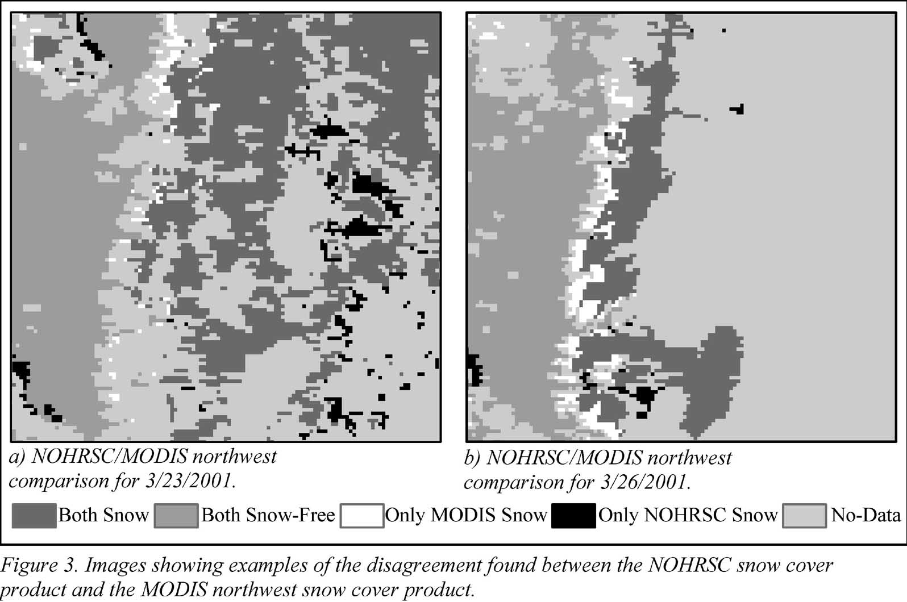
 | Percent of Pixels that Agree | KHAT Statistic | Percent of Pixels Both Agree Bare Land | Percent of Pixels MODIS Snow/NOHRSC Bare Land | Percent of Pixels NOHRSC Snow/MODIS Bare Land | Percent of Pixels Both Agree Snow
03/23/01 | 93.0 | 83.6 | 65.5 | 3.9 | 3.2 | 27.5
<25% Forest | 96.7 | 77.3 | 90.3 | 0.9 | 2.5 | 6.3
25%-50% Forest | 90.1 | 80.2 | 46.5 | 4.1 | 5.8 | 43.6
50%-75% Forest | 83.4 | 39.8 | 8.1 | 11.3 | 5.3 | 75.3
>75%Forest | 86.1 | 53.1 | 10.7 | 12.6 | 1.3 | 75.4
03/26/01 | 96.9 | 51.6 | 95.2 | 2.1 | 1.0 | 1.7
<25% Forest | 98.8 | 28.1 | 98.6 | 0.8 | 0.4 | 0.2
25%-50% Forest | 89.6 | 49.0 | 83.3 | 4.8 | 5.6 | 6.3
50%-75% Forest | 73.6 | 49.7 | 39.2 | 24.7 | 1.7 | 34.4
>75%Forest | 56.1 | 25.4 | 32.9 | 43.6 | 0.3 | 23.2
Table 5. Statistics for example dates between NOHRSC and MODIS northwest snow cover maps showing agreement, KHAT statistic, individual agreements and disagreements between the snow cover comparisons. Also shown are the individual comparisons stratified by percent forest cover.
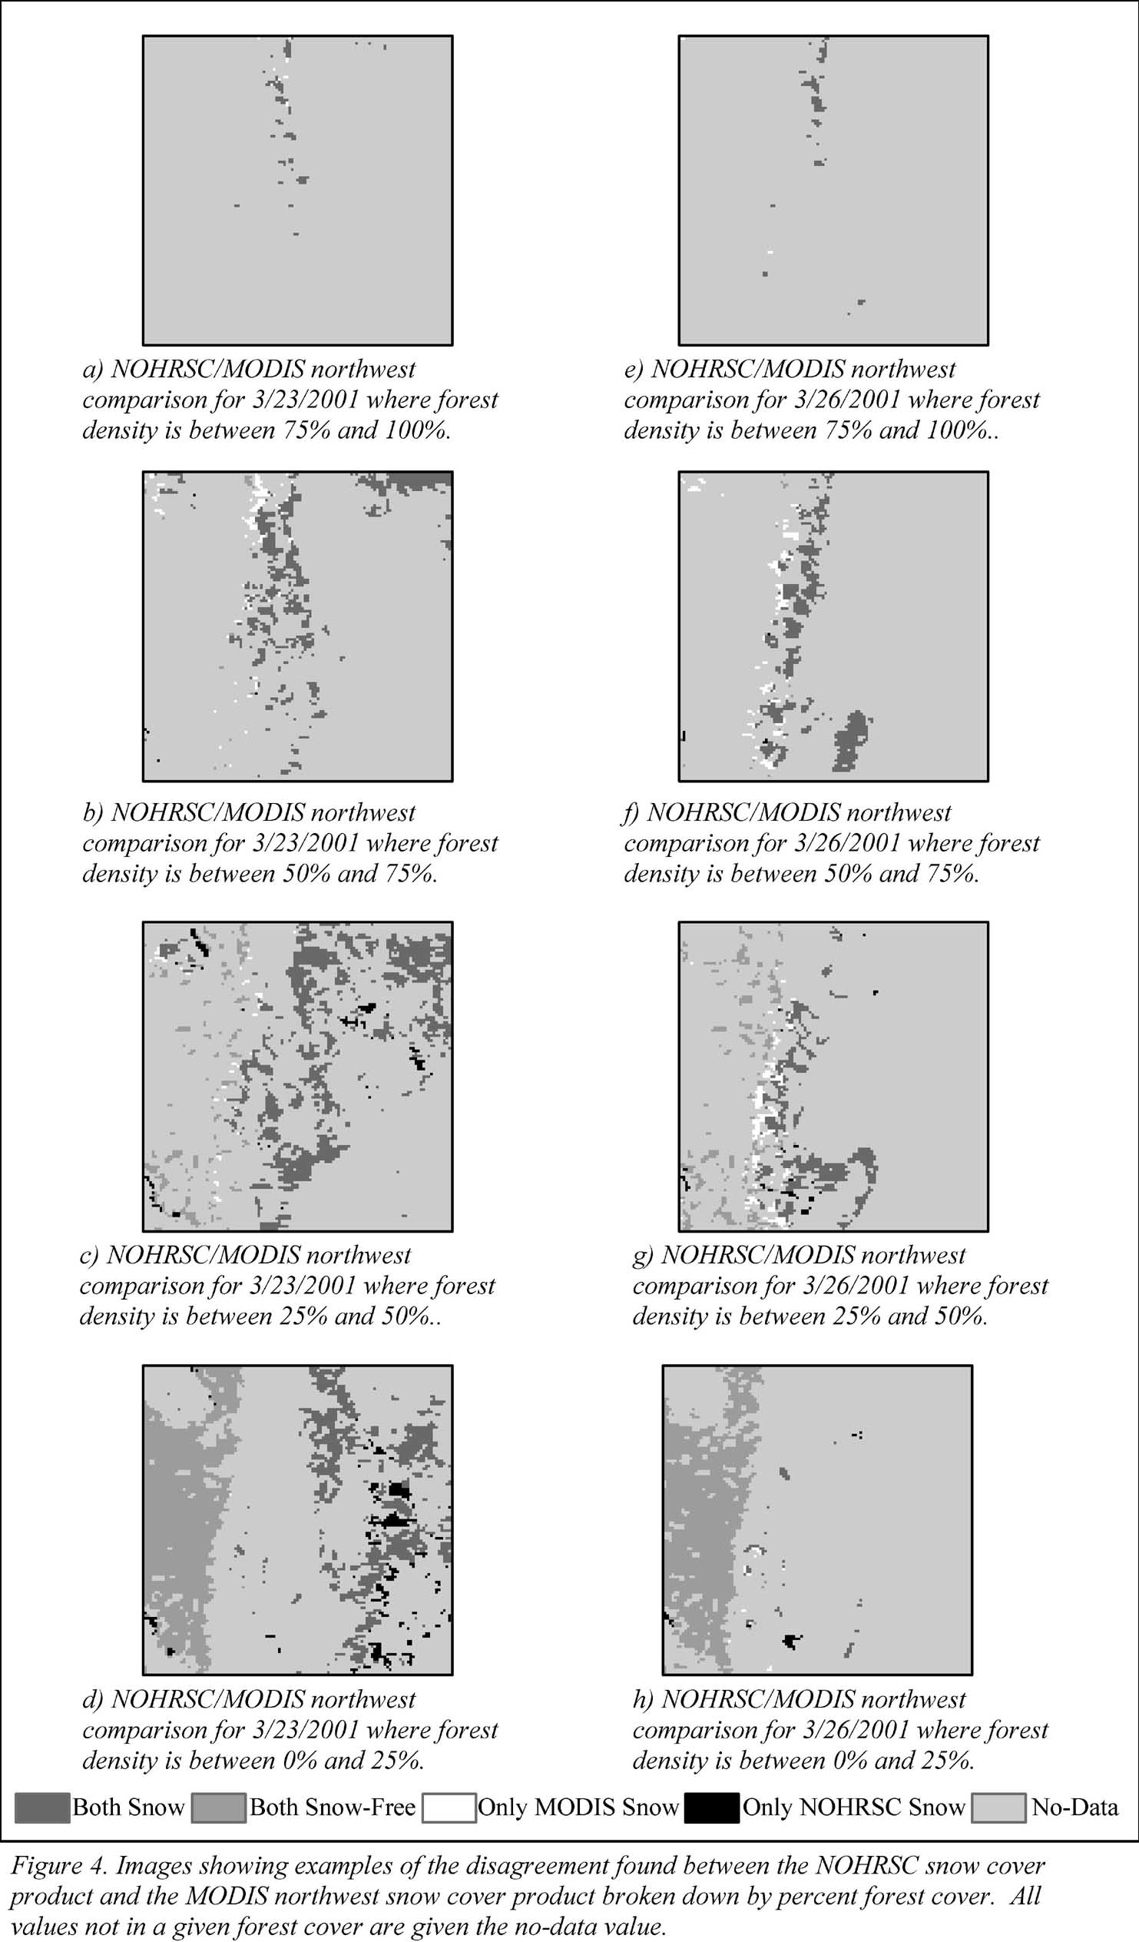

DISCUSSION

This study compared snow cover maps created at the NOHRSC at a nominal resolution of 1 km using an interactive mapping procedure with maps that were created automatically at different resolutions using different sensors and algorithms. NOHRSC snow cover maps were compared with maps created by NESDIS at a resolution of about 5 km for the coterminous U.S. for 32 different dates from November 2000 through February 2001. NOHRSC snow cover maps were also compared for two adjacent areas in the northwestern U.S. with snow cover maps created using MODIS data at a resolution of 500m for 18 and 21 dates from March 2001 through June 2001.

The resampling technique used in this study, while eliminating the mixed pixel problem, had the effect of smoothing the data. This smoothing limited the edge effects when comparing images of different resolutions. When more of the total snow pack was near or on an edge, as happened when the snow was melting and became limited to the mountains, this smoothing became more pronounced. In the NOHRSC/NESDIS study, there were large areas of continuous snow pack, and the effects of the resampling were minimal. In the NOHRSC/MODIS study areas, the snow was often limited to discontinuous areas. The resampling technique minimized the edge effect caused solely by the difference in resolution between the two snow cover maps. Remaining differences between the two techniques around the edges of the snow pack indicated that there were differences between the snow mapping techniques.

While the NOHRSC and the NESDIS maps had consistently high agreement and KHAT statistics, there was a small general bias of the NESDIS approach mapping more snow than the NOHRSC technique. This bias was seen in every date compared, and it did not vary with respect to percent forest cover. This indicates that there was some other systematic difference between the two snow mapping techniques.

The agreement between each set of snow maps in the NOHRSC/MODIS comparisons, when resampled to match the coarsest relevant resolution, was quite high (94% and 95% agreement). The KHAT statistic indicated that while overall the agreement was high, there were major differences in the snow being mapped. Because this study used Spring data, there were two factors which limited the amount of snow mapped by both techniques. First, the large contiguous areas of snow had already begun to melt and much of the snow was limited to the areas of higher elevation. Second, a large amount of cloud cover existed over the study areas throughout much of the study. Both factors resulted in a more discontinuous, patchy snow cover, located primarily in mountainous areas with greater forest cover. The differences in snow cover maps in these locations appear to be due to the differences between the two mapping techniques in forest cover.

The NOHRSC/MODIS comparisons clearly showed that the MODIS snow-mapping technique mapped more snow in forests than did the NOHRSC approach. It also showed that where there is little to no forest cover, the NOHRSC snow-mapping technique mapped more snow than did the MODIS approach. This indicates that there are differences in the ability of these two approaches to map snow under forests. The use of the NDVI allows the MODIS snow mapping approach to adjust the threshold at which snow is mapped based upon the amount of vegetation in an area. In the NOHRSC snow mapping approach, this threshold is adjusted manually based on visual interpretation of the visible band. Once the edge of the snow pack has been found, a NOHRSC analyst is able to adjust the threshold used to map snow within the perimeter of this snow pack to create a continuous area of snow.

CONCLUSIONS

The NOHRSC and NESDIS snow cover products were quite similar when compared at a 5 km resolution. The NESDIS map, however, showed a slight bias towards mapping snow that the NOHRSC does not. The comparison between the NOHRSC and the MODIS snow cover products showed a large disparity at the edges of the snow pack. There was a large disparity in how the NOHRSC and MODIS snow-mapping techniques mapped snow in forested areas. During this study, much of the snow pack edge was located in forested areas. The NOHRSC snow mapping technique was not able to map the edge of the snow pack in tree-covered areas as readily as the MODIS approach. Within the perimeter of a snow pack, however, the NOHRSC approach mapped a more continuous snow pack when compared to the MODIS snow cover product. The study suggests that in the mid-winter when there tends to be a continuous snow pack, there should be good agreement between the NOHRSC snow cover product and both the NESDIS and the MODIS snow cover products. When large areas of discontinuous snow cover occur in the forested areas of the mountains, however, the MODIS product should tend to map more discontinuous snow cover under the forest canopy than the NOHRSC technique.

ACKNOWLEDGEMENTS

This study was funded, in part, by a grant from the NOAA Office of Global Programs and the Global Energy and Water Cycle Experiment (GEWEX) GEWEX Americas Prediction Project (GAPP) office. The MODIS snow cover products were provided by the National Snow and Ice Data Center in Boulder, Colorado. The NESDIS snow cover products were provided by NOAA/NESDIS in Camp Springs, Maryland.

REFERENCES

Cline, Donald W, and Thomas R Carroll. 1999. Inference of Snow Cover Beneath Obscuring Clouds using Optical Remote Sensing and a Distributed Snow Energy and Mass Balance Model. Journal of Geophysical Research, 104,D16:19,631-19,644.

Congalton, RG 1991. A Review of Assessing the Accuracy of Classifications of Remotely Sensed Data. Remote Sensing of Environment, 37:35-46.

Hall, DK, AB Tait, GA Riggs, and VV Salomonson. 2000-2001: MODIS/Terra Snow Cover Daily L3 Global 500m ISIN Grid, Version 3. Boulder, CO, USA: National Snow and Ice Data Center. FTP.

Hall, DK, AB Tait, GA Riggs, and VV Salomonson. 2001: Algorithm Theoretical Basis Document for the MODIS Snow and Sea Ice-Mapping Algorithms. Laboratory for Hydroshperic Sciences, National Aeronautics and Space Administration, Greenbelt, MD, USA.

Hall, DK, JL Foster, VV Salomonson, AG Klein, and JYL Chien. 2001: Development of a technique to Assess Snow-Cover Mapping Errors from Space. IEEE Transactions on Geoscience and Remote Sensing, 39(2).

Maurer, Edwin P, Joshua D Rhoads, Ralph O Dubayah, and Dennis P Lettenmaier. 2002: Evaluation of the Snow-Covered Area Data Product from MODIS in the context of Continental-Scale Hydrologic Modeling. (in press).

Romanov, Peter, Garik Gutman, and Ivan Csiszar. 2000: Automated Monitoring of Snow Cover over North America with Multispectral Satellite Data. Journal of Applied Meteorology, 39:1866-1880.

Zhu, Zhilaliang, David Evans. 1994: U.S. Forest Types and Predicted Percent Forest Cover from AVHRR Data. Photogrammetric Engineering & Remote Sensing, 60:525-531.

Paper Presented at the Western Snow Conference 2002 ?National Operational Hydrologic Remote Sensing Center, National Weather Service, National Oceanic and Atmospheric Administration, 1735 Lake Drive West, Chanhassen, Minnesota, 55317
National Environmental Satellite, Data, and Information Service, National Oceanic and Atmospheric Administration, Camp Springs, Maryland 20746

